 | 
LAB 6: Smart Notification System using Telegram and Home Assistant | School of Applied Digital Technology
Name:  Name: | ID:  ID: | Section:  Section:
Date: | Due date:

Objectives
- To configure Telegram Bot with Home Assistant for real-time alert notifications.
- To create automations that trigger alerts when sensors detect abnormal conditions.
- To demonstrate a simple IoT smart home notification system.

Equipment and Software
Item | Description
💻 Home Assistant (Docker) | Main automation server
🧠 ESPHome + ESP32 | Microcontroller with sensors
🌡️ DHT11 | Temperature and Humidity sensor
💨 MQ-2 | Gas and smoke sensor
🚶 HC-SR501 | PIR motion sensor
🔔 Buzzer / LED | Alert indicators
🤖 Telegram App | Notification platform
Step 1 – Download and Install Telegram
Before creating your Telegram Bot, make sure the Telegram application is installed on your device.
- For Mobile (Recommended)
1. Visit https://www.telegram.org
2. Choose Android or iPhone / iPad.
3. Tap Download Telegram to open the Play Store or App Store.
4. Install the app and open it after installation.
5. Sign in using your phone number and verification code.
- For Desktop (Windows / macOS / Linux)
1. Go to https://www.telegram.org or the main site’s Get Telegram for PC / Mac section.
2. Select your operating system (Windows, macOS, or Linux).
3. Download the installer file and follow the on-screen instructions.
4. After installation, log in by scanning the QR code with your mobile Telegram app or entering your phone number.
💡Tip
• Using the same Telegram account on both mobile and desktop lets you receive Home Assistant alerts anywhere.
• Once Telegram is installed and logged in, you can proceed to Step 1 – Create a Telegram Bot from the Lab 6 document.

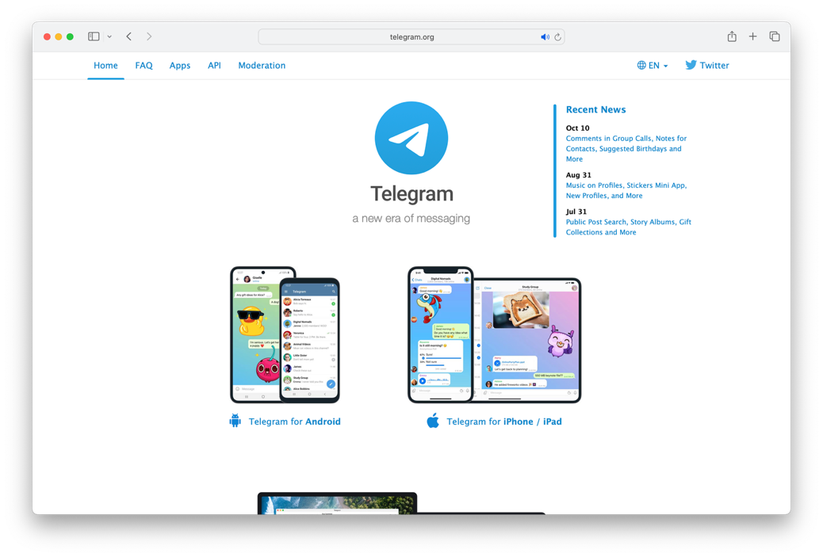

Step 2 – Create a Telegram Bot
- Open Telegram → search for @BotFather.

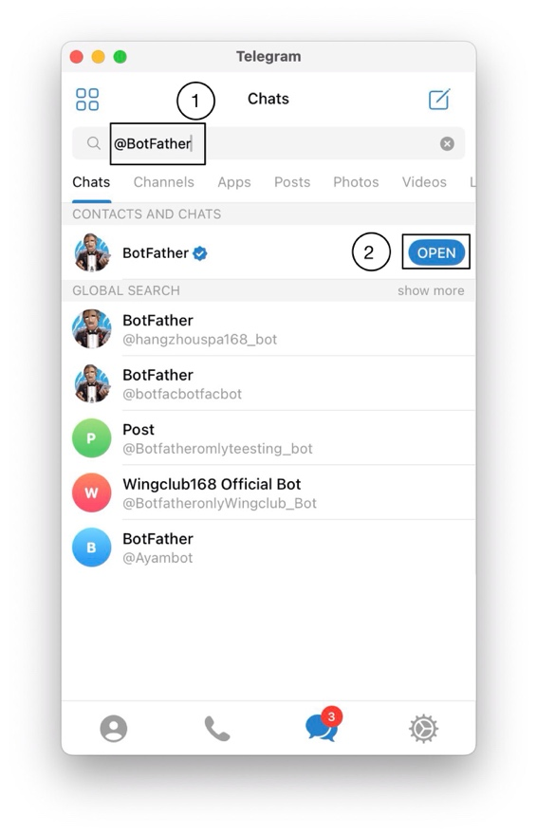

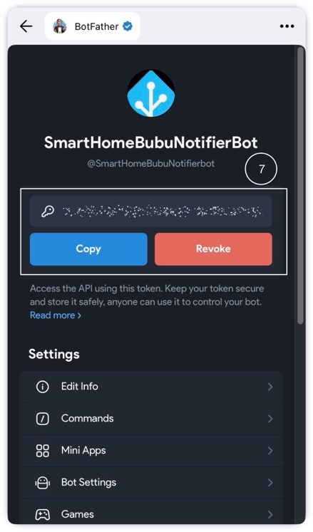
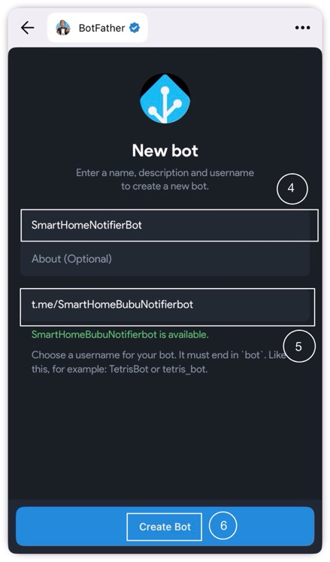

- 👉 Copy the API Token — it will be used in Home Assistant.
Step 3 – Start the Bot Conversation
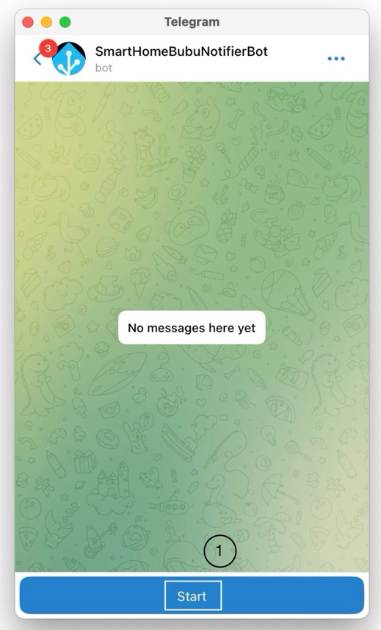
⚠️ This step is required — otherwise Telegram will block all messages sent from Home Assistant.
- Open the link of your bot, e.g.
https://t.me/SmartHomeBubuNotifierBot
- Click Start
- Once it replies “You started this bot”, it’s ready for use ✅

Step 4 – Get Your Chat ID
- In Telegram, search for @userinfobot.
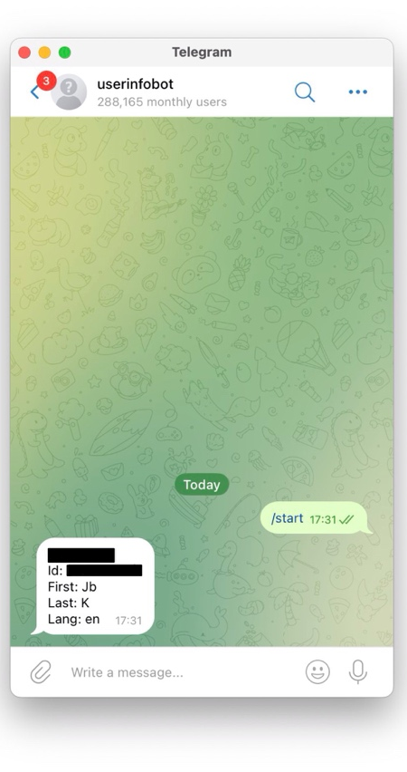
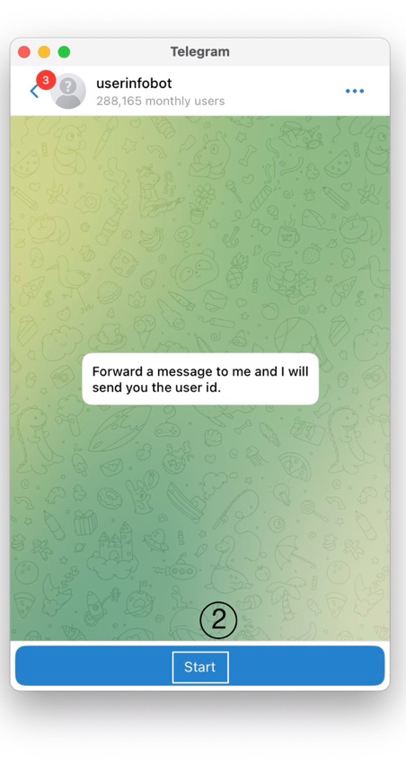
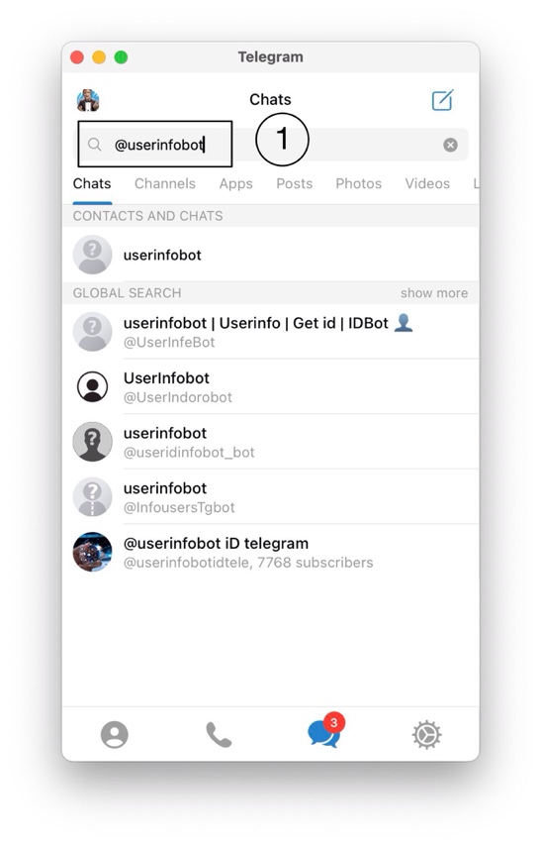
- Click Start, and you will receive a message like:

➤ This number is your Chat ID.
Step 5 – Configure Telegram in Home Assistant
- Edit your configuration.yaml file and add the following block at the end:
Yaml:
# ==============================
# 🔔 Telegram Notification Setup
# ==============================
telegram_bot:
- platform: polling
api_key: "xxxxxxxxxxxxxxxxxxxxxxxxxxxx " # ← Replace with your own Token
allowed_chat_ids:
- 987654321 # ← Replace with your own Chat ID
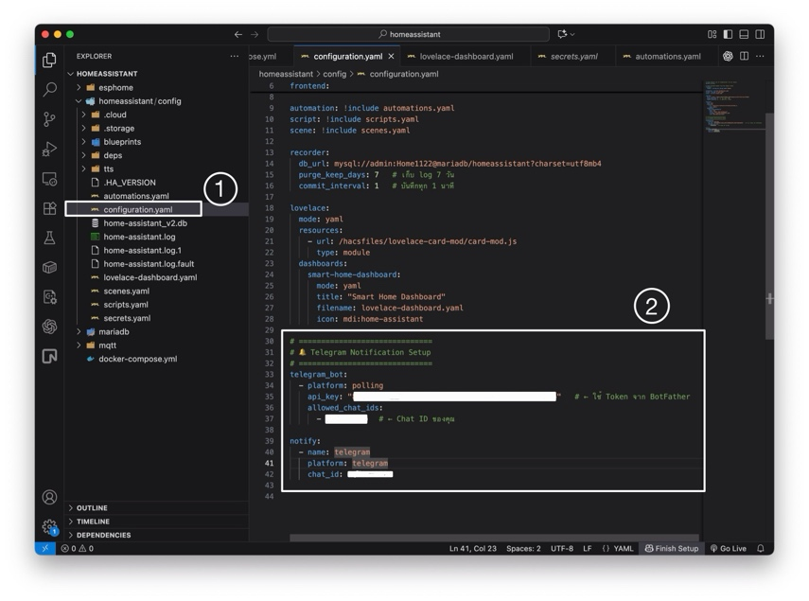
notify:
- name: telegram
platform: telegram
chat_id: 987654321

💡 Tip: For better security, store the token and chat ID in secrets.yaml like:
Step 6 – Check Configuration and Restart
- Go to Developer Tools → YAML → Check Configuration
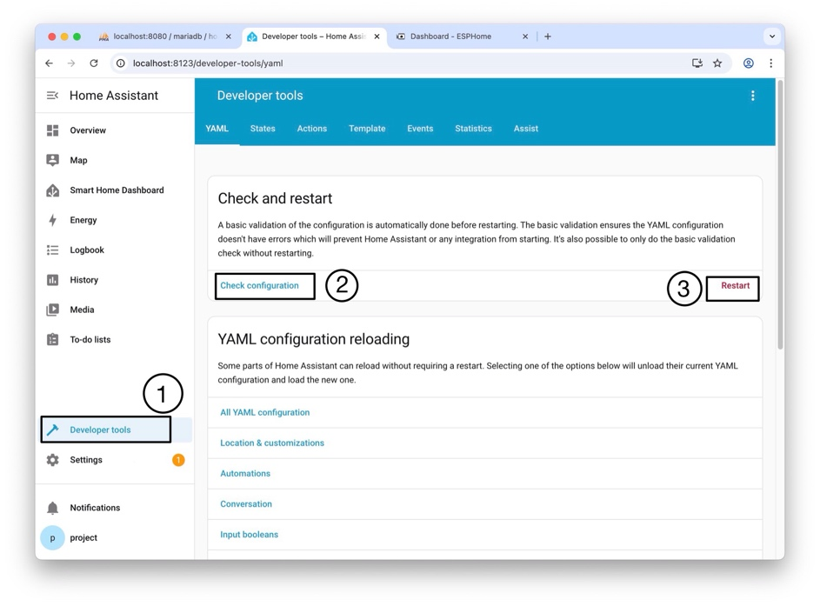
- If no errors appear → Go to Settings → System → Restart

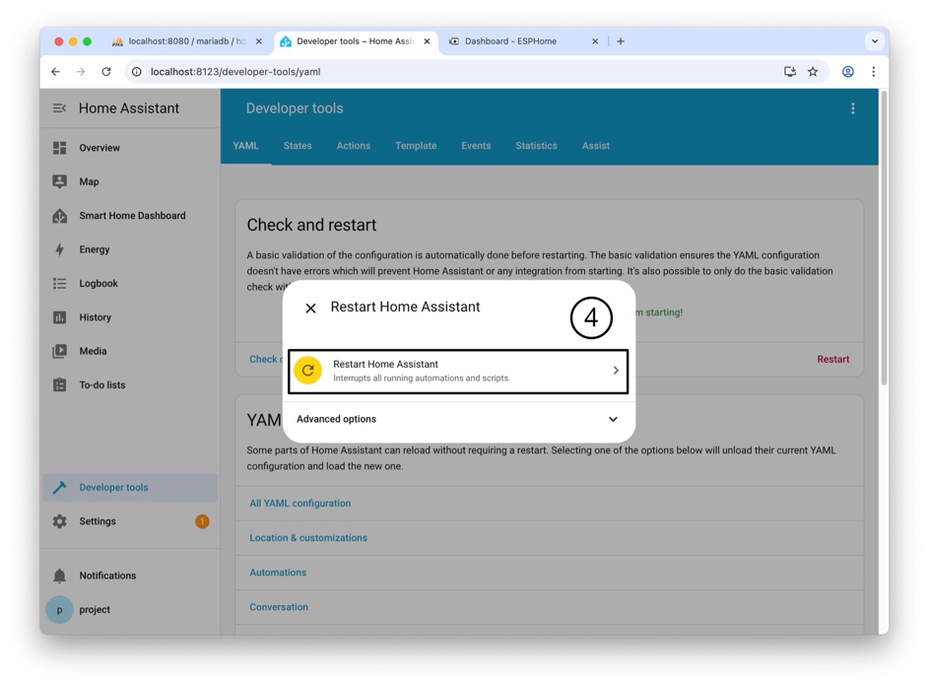

Step 7 – Test Telegram Notification
- Go to Developer Tools → Actions
- Paste this YAML snippet:
Yaml:
action: notify.telegram
target: {}
data:
message: "✅ Test message from Home Assistant!"
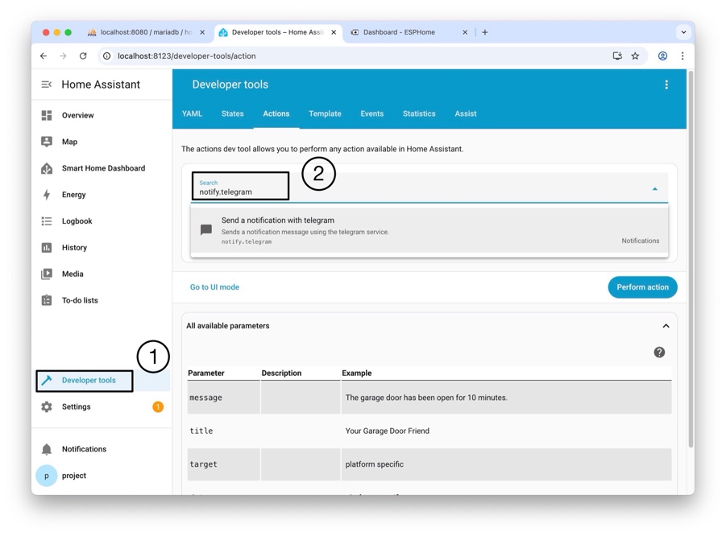

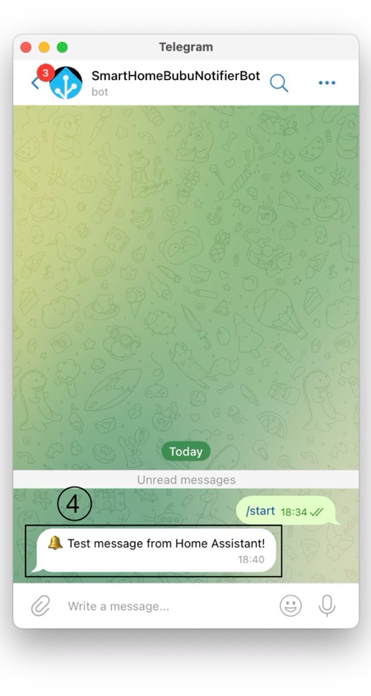
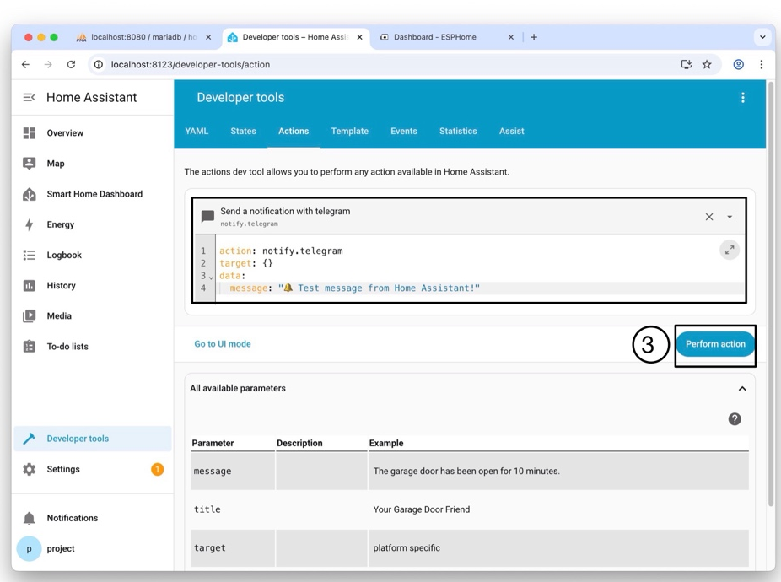

- Click Perform action
📱 If you see a message in Telegram saying
“✅ Test message from Home Assistant!”
then your integration works perfectly 🎉

Step 8 – Create Automation Rules
- Open the file /config/automations.yaml and add these automations:
Yaml:
# =========================================
# 🚨 Automation 1: Gas Detection Alert
# =========================================
- alias: "Alert: Gas Detected"
trigger:
- platform: state
entity_id: binary_sensor.gas_alarm_active
to: "on"
action:
- service: notify.telegram
data:
message: "⚠️ Gas detected! Please check immediately!"
- service: switch.turn_on
entity_id: switch.active_buzzer
- delay: "00:00:10"
- service: switch.turn_off
entity_id: switch.active_buzzer

# =========================================
# 🚶 Automation 2: Motion Detection Alert
# =========================================
- alias: "Alert: Motion Detected"
trigger:
- platform: state
entity_id: binary_sensor.living_room_motion
to: "on"
action:
- service: notify.telegram
data:
message: "🚶 Motion detected in the living room!"

# =========================================
# 🌡️ Automation 3: High Temperature Alert
# =========================================
- alias: "Alert: High Temperature"
trigger:
- platform: numeric_state
entity_id: sensor.living_room_temperature
above: 32
action:
- service: notify.telegram
data:
message: >
🔥 High temperature alert!
Current temperature: {{ states('sensor.living_room_temperature') }} °C

- After saving the file, reload automations:
Yaml:
action: automation.reload
target: {}
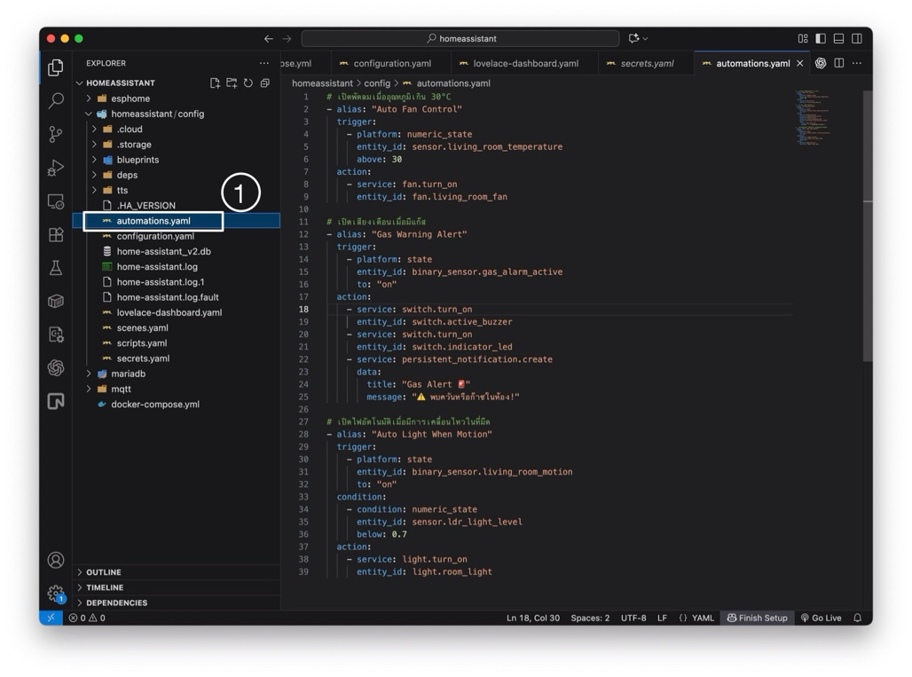
data: {}

Take 1: Combined Smart Alert (Bonus)
Requirements
- Create one automation that sends a detailed summary report to Telegram.
whenever any of the following occurs:
• Gas alarm ON
• Motion detected
• Temperature > 32 °C
- The message must include:
• Current values of all sensors
• Timestamp ({{ now().strftime('%H:%M:%S') }})
• Room location
- Use multiline message format (>)
- Test the automation by simulating one condition

Continued on the next page.
Code:

----- Have a good day -----
Answer:
- alias: "Smart Combined Alert"
trigger:
- platform: state
entity_id: binary_sensor.gas_alarm_active
to: "on"
- platform: state
entity_id: binary_sensor.living_room_motion
to: "on"
- platform: numeric_state
entity_id: sensor.living_room_temperature
above: 32
action:
- service: notify.telegram
data:
message: >
🚨 *Smart Home Alert*
🕒 Time: {{ now().strftime('%H:%M:%S') }}
🌡 Temperature: {{ states('sensor.living_room_temperature') }} °C
💨 Gas Level: {{ states('sensor.mq_2_gas_level') }}
🚶 Motion: {{ states('binary_sensor.living_room_motion') }}
📍 Location: Living Room
✅ Please check your environment immediately.

